Planning and Environment Act 1987

WHITTLESEA PLANNING SCHEME AMENDMENT C257WSEA EXPLANATORY REPORT

Who is the planning authority?

This Amendment has been prepared by the Minister for Planning, who is the planning authority for this Amendment.
The Amendment has been made at the request of the Melbourne Water Corporation.

Land affected by the Amendment

The Amendment applies to part of the land at 115 Trawalla Avenue, Thomastown. The part of the land subject to the amendment is outlined in yellow hatching on the aerial photograph below.
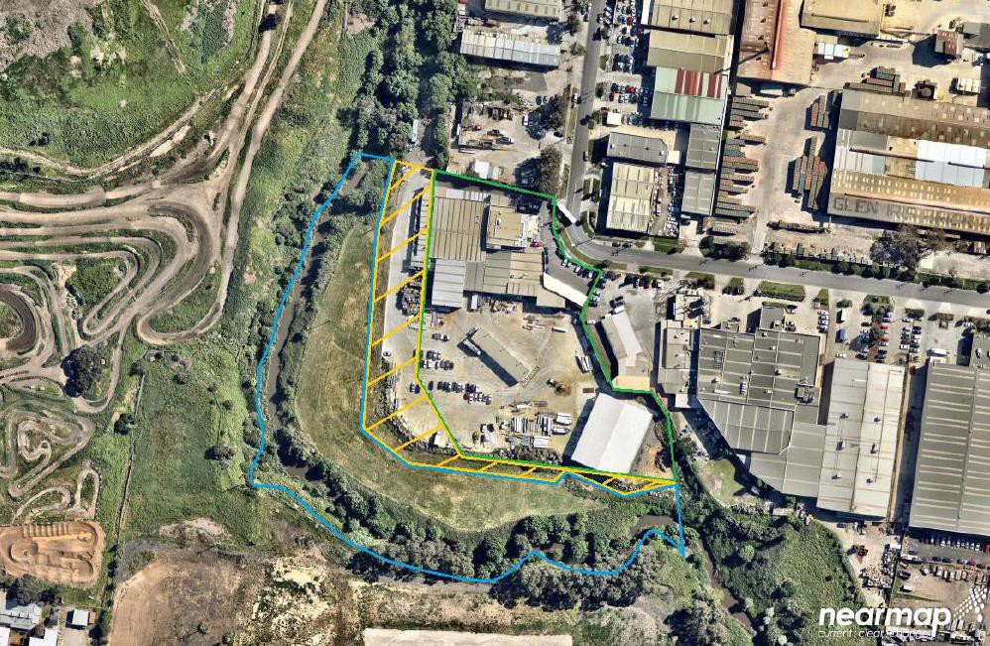

What the amendment does

The Amendment proposes to change the planning provisions for land that is owned by Melbourne Water and has been determined to be surplus to government requirements.
The Amendment proposes to rezone the land to from a Public Use Zone – Service and Utility (PUZ1) to the Industrial 1 Zone and apply the Development Contributions Plan Overlay – Schedule 3 to the land.

Strategic assessment of the Amendment

Why is the Amendment required?

The Victorian Government Landholding Policy and Guidelines 2015 requires Victorian Government departments and agencies to review and manage their land assets on an on-going basis. Part of this assessment includes determining if land assets are required for a current and future service delivery need.

Where land is no longer needed for a public purpose, this land must be declared surplus to requirements and disposed of, in accordance with the Victorian Government Land Transactions Policy and Guidelines 2015. Land owned by the Government is often zoned for public use to recognise the public purpose and ownership of the site.
Melbourne Water has determined that the land is surplus to its requirements.

Historically, Melbourne Water has leased the land under licence to the adjoining industrial landowner for more than a decade. Several buildings, structures and areas of hardstand have been constructed on the land by the leaseholder since the lease commenced.

A planning permit has been granted by the City of Whittlesea (Planning Permit No. 716537) to remove the public reserve status of the land and Melbourne Water has approval from the Victorian Government Land Monitor to sell the land directly to the adjoining landowner at 67 Trawalla Avenue, Thomastown, by virtue of its landlocked status.

To facilitate disposal, the land must be rezoned to reflect an appropriate alternative zone. The Victorian Government Land Transaction Policy and Guidelines 2015 require that the most appropriate zoning be put in place prior to the sale of the land.

The Amendment rezones the land from the Public Use Zone to reflect that it is not required for a public use.

The Amendment proposes to rezone the land to the Industrial 1 Zone, which reflects the zoning of the adjoining land at 67 Trawalla Avenue, Thomastown.

How does the Amendment implement the objectives of planning in Victoria?

The Amendment implements the objectives for planning in Victoria, set out at section 4 of the Planning and Environment Act 1987. In particular, the Amendment implements the following objectives:
- to provide for the fair, orderly, economic and sustainable use, and development of land;
- to provide for the protection of natural and man-made resources and the maintenance of ecological processes and genetic diversity;
- to facilitate development in accordance with the objectives set out in the other objectives;
- to balance the present and future interests of all Victorians.
The Amendment responds to these objectives by consolidating residential land and protecting significant vegetation. The Amendment will create appropriately zoned land for future industrial development within an established industrial area.

How does the Amendment address any environmental, social and economic effects?

Environment

The amendment will rezone land that is located in proximity to Merri Creek, which is a sensitive creek environment. Policy settings within the Whittlesea Planning Scheme seek to protect and improve the environmental condition of the creek corridor.

As part of the sale of the land and planning permit to facilitate the subdivision of the land, landscaping works are expected to occur in the creek corridor. The landscaping works and planting regime for the creek corridor have been developed in consultation with the Merri Creek Management Committee and Whittlesea City Council.

Early preparatory works on landscaping and weed management commenced in December 2020 and are likely to be completed by the end of 2022. These landscaping and weed management works will

result in an improved environmental condition to the creek corridor on the land affected by the amendment.

The amendment also maintains an appropriate buffer between the Merri Creek and the industrial activity, with the remainder of the land at 115 Trawalla Avenue, Thomastown to remain as a public reserve in favour of Melbourne Water.
Social
The amendment will facilitate the development of vacant land that has become surplus to Melbourne Water’s requirements. The amendment is expected to have generally positive social effects by allowing an underutilised site to contribute to future industrial employment needs.

Economic
The amendment is expected to generate positive economic effects.

The adjoining industrial enterprise is a significant employer in the local and regional context, employing over 400 staff. The rezoning and transfer of the land to the industrial operator will enable a
$40 million expansion of the business. The expansion is estimated to create an additional 80 jobs as part of its first stage, with the potential for a further 120 jobs to be created in later stages.

The funds realised through the sale of government land will be reinvested into new infrastructure and services across Victoria.

Does the Amendment address relevant bushfire risk?

The land is not within a Bushfire Management Overlay. Part of the land is within a bushfire prone area.

The Amendment will not result in any significant change to the pattern of land use and development on the site or in the surrounding area. The land is extensively developed with hardstand areas and firefighting equipment is available on premises.

The Amendment supports the policy of Clause 13.02 Bushfire risk by encouraging development in low risk locations.

Does the Amendment comply with the requirements of any Minister’s Direction applicable to the amendment?

This amendment is consistent with the Ministerial Direction on the Form and Content of Planning Schemes under Section 7(5) of the Act.
Ministerial Direction No. 9 – Metropolitan Planning Strategy seeks to ensure that planning scheme amendments have regard to Plan Melbourne 2017-2050: Metropolitan Planning Strategy.
The amendment is consistent with policy directions in Outcome 1 of Plan Melbourne, which seek to ensure that Melbourne is a productive city that attracts investment, supports innovation and creates jobs.

Ministerial Direction No. 11 – Strategic Assessment of Amendments seeks to ensure a comprehensive strategic evaluation of a planning scheme amendment and the outcomes it produces.
A strategic assessment of the proposed amendment has been undertaken in accordance with this Ministerial Direction in this explanatory report.

How does the Amendment support or implement the Planning Policy Framework and any adopted State policy?

The elements of the Planning Policy Framework that are most relevant to the Planning Scheme Amendment relate to settlement planning, environmental and landscape values and industrial land policy.
Clause 11.01-1R ‘Settlement – Metropolitan Melbourne’ provides that planning is to anticipate and respond to the needs of existing and future communities through the provision of zoned and serviced land for housing, employment, recreation and open space, commercial and community facilities and infrastructure. Planning is to facilitate sustainable development that takes full advantage of existing settlement patterns, and investment in transport and communication, water and sewerage and social facilities. Promote and capitalise on opportunities for urban renewal and infill redevelopment.
Local policy at Clause 11.01-1L ‘Settlement – City of Whittlesea’ seeks to ensure suitable amounts of industrial land are available in appropriate locations. Relevantly, the land is identified as being ‘industrial/employment land’ on the Municipal Strategic Framework Plan at Clause 02.04 of the Whittlesea Planning Scheme.
The land subject to the Amendment is within an established industrial precinct. The proposed development will facilitate an orderly planning outcome by facilitating the land uses that currently exist on the site, whilst also supporting the area’s local industrial economy and facilitating the provision of industrial land in an appropriate location.
Clause 12 ‘Environmental and Landscape Values’ seeks to ensure that planning protects sites that have environmental and landscape values.
Particularly, Clause 12.01-1L ‘Protection of biodiversity’ seeks to facilitate the provision of buffers along waterways and between sites of biodiversity value and urban infrastructure. It encourages the revegetation of waterway corridors and seeks to protect habitat areas in creek valleys (among other locations).
Clause 12.03-1S ‘River corridors, waterways, lakes and wetlands’ seeks to protect and enhance river corridors, waterways, lakes and wetlands. It seeks to ensure that development is sensitively designed and sited to maintain and enhance environmental assets and significant views and landscapes along river corridors.
The amendment provides for the ongoing protection of the waterway corridor. The land is affected by an Environmental Significance Overlay which will continue to apply to the land. The proposed landscaping, revegetation and weed management works on the land will protect the waterway buffer and enhance the creek environment.
In terms of industrial land policy, Clause 17.01-1S ‘Diversified economy’ seeks to strengthen and diversify the economy. Clause 17.01-1L ‘Diversified economy’ seeks to support the allocation of employment growth in Thomastown, Epping, Bundoora and South Morang. It particularly encourages industrial and other employment generating uses in the Thomastown industrial area and seeks to progressively increase the supply of land zoned for employment purposes.
Clause 17.03-1S ‘Industrial land supply’ similarly encourages an adequate supply of industrial land in appropriate locations.
The amendment will meet the direction in policy at Clause 17 by providing for additional supply of land zoned for industrial purposes and locating the new supply in the designated industrial area in Thomastown.

How does the Amendment support or implement the Municipal Planning Strategy?

The Municipal Planning Strategy recognises the importance of industry to Whittlesea’s local economy.
Clause 02.01 ‘Context’ highlights that the City’s three highest industry sector employers are manufacturing, retail and trade.

The Vision at Clause 02.02 seeks to grow the local economy. This is supported by Clause 02.03 ‘Strategic Directions’, which recognises that the strong manufacturing base is the greatest asset of the local economy. Council aims to plan for employment growth by increasing the choice and location of land available for industry and other employment generating uses and supporting economic activity that is responsive to the investment and employment needs of the community, in a manner that has respect for the environment.

The Strategic Framework Plans at Clause 02.04 recognise that the land within the amendment area is identified as industrial/employment land.

The amendment is consistent with these aspirations to provide adequate industrial land supply for the local economy.

Does the Amendment make proper use of the Victoria Planning Provisions?

The amendment proposes to rezone the land to the Industrial 1 Zone. The Purpose of the Industrial 1 Zone is:
To implement the Municipal Planning Strategy and the Planning Policy Framework.
To provide for manufacturing industry, the storage and distribution of goods and associated uses in a manner which does not affect the safety and amenity of local communities.
The land adjoins an established heavy industrial precinct that is used for a range of manufacturing, food processing and fabrication land uses. The subject site itself is leased from Melbourne Water and currently used in conjunction with the food processing operations that take place at 67 Trawalla Avenue.
Within this context, the Industrial 1 Zone is the most appropriate tool to facilitate the future use and development of the land for industrial purposes.
The retention of the Environmental Significance Overlay and Land Subject to Inundation Overlay is appropriate to ensure the environmental condition of land close to the Merri Creek can be managed appropriately.
The application of the Development Contributions Plan Overlay allows for development contributions to be collected on private land, in accordance with the requirements of the Development Contributions Plan that applies more broadly across the municipality.
The application of these controls make proper use of the Victorian Planning Provisions and will not make any existing provisions within the Whittlesea Planning Scheme redundant.

How does the Amendment address the views of any relevant agency?

The amendment has considered the views of Melbourne Water, relevant to its obligations for the waterway, the land and adjoining land.
The amendment is not likely to affect any other government agencies. However, the amendment has been prepared in consultation with the local council and important community groups, including the Merri Creek Management Committee. The views of these stakeholders have been considered in the preparation of the amendment and the finalisation of landscaping, revegetation and weed management plans for the land affected by the amendment.

Does the Amendment address relevant requirements of the Transport Integration Act 2010?

The amendment meets the requirements of the Transport Integration Act 2010.
The amendment is not envisaged to have a significant effect on the transport system.

Resource and administrative costs

- What impact will the new planning provisions have on the resource and administrative costs of the responsible authority?

The Amendment will not result in any significant impact on the resources and administrative costs of Council.

ATTACHMENT 1 - Mapping reference table

Location | Land /Area Affected | Mapping Reference
Thomastown | Part 115 Trawalla Avenue, Thomastown | Whittlesea C257wsea znMap20

